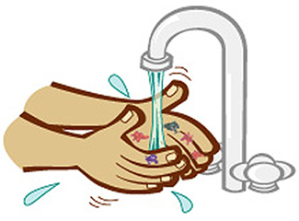
INFECTION CONTROL

Our Practice Lead for Infection Control is Alison Hart-Bettany (ANP/Nurse Lead). She attends regular forums, conferences and study days and brings back up to date evidence based information to the practice to continually improve the standards of infection control.

Alison performs an annual Infection Control Audit which is conducted to ascertain the standards of infection control at both AMC and Aston branch surgery. The audits are carried out using the Care Setting Process Improvement Tool GP Surgery/Health Centre supported and recommended by the local the Southern Derbyshire CCG. The audit concludes with a list of recommendations to the Practice Manager and GP Partners on how standards of infection control may be improved.

In the past 3-4 years Alvaston Medical Centre has invested in improving the standards of infection control across both sites in the following ways:

- All clinical areas now have floor coverings that are washable and impervious to moisture as per recommendations
- All of the waiting room and patient consultation chairs have been replaced with impermeable and washable materials as per recommendations
- New plug and overflow sinks with elbow operated taps fitted to all clinical rooms
- New splashbacks behind clinical sinks
- 4 New examination couches
- 3 monthly walk around/audit with contracted cleaning company to ensure high standards of cleaning are maintained
- Equipment cleaning schedules in all clinical rooms and monitoring
- Up to date and evidence based practice policies for infection control
- Infection prevention and control related topics are regular agenda items at staff/business meetings
- In house training for all staff in all subjects relating to infection control
- In house Infection control training as part of new staff members induction
- Regular Hand washing audits
- Untoward incidences are reported as part of the practice significant event process
- New protocols for segregation of clinical waste to reduce impact on climate change and reduce cost

Future Plans:
- Wall mounted hand soap and alcohol gel dispensers in all clinical rooms
- Wall mounted glove & apron holders in all clinical rooms
- External secure container for clinical waste
AHB June 2021

